05/09/13

CAP 224

Digital Environment
Plan of Instruction

Effective Date: Spring 2013 Version Number: 2013-1

COURSE DESCRIPTION:

This course introduces students to matte painting techniques and specialized CGI environment software. Topics include concepts art, camera projection, light repainting, atmosphere and various tools available in virtual environment creation software. Upon completion, the student should be able to create a realistic environment using various photographic and CGI sources.

CREDIT HOURS

Theory Credit Hours 1 hour
Lab Credit Hours 2 hours
Total Credit Hours 3 hours

NOTE: Theory credit hours are a 1:1 contact to credit ratio. Colleges may schedule lab hours as 3:1 and/or 2:1 contact to credit ratio. Clinical hours are 3:1 contact to credit ratio. (Ref Board Policy 705.01)

PREREQUISITE COURSES

CAP 121, CAP 123

CO-REQUISITE COURSES

As determined by college.

PROFESSIONAL COMPETENCIES
- Use Vue D’esprit to create digital environment assets.
- Use Photoshop to integrate various assets toward the creation of digital environments.

INSTRUCTIONAL GOALS

- Cognitive – Comprehend principles and concepts related to the creation of virtual environments.

- Psychomotor – Apply principles digital environment creation.

- Affective – Value the importance of using assets from various sources for the creation of digital environment.

STUDENT OBJECTIVES

Condition Statement: Unless otherwise indicated, evaluation of student’s attainment of objectives is based on knowledge gained from this course. Specifications may be in the form of, but not limited to, cognitive skills diagnostic instruments, manufacturer’s specifications, technical orders, regulations, national and state codes, certification agencies, locally developed lab/clinical assignments, or any combination of specifications.

STUDENT LEARNING OUTCOMES

MODULE A – CGI ASSETS CREATION FOR ENVIRONMENTS
MODULE DESCRIPTION – This module instructs students on the use of Vue D’esprit Software toolset. Topics include interface workflow, material, plants, atmosphere, ecosystems, water surfaces, animation, and rendering options.
PROFESSIONAL COMPETENCIES | PERFORMANCE OBJECTIVES | KSA
A1.0 Use Vue D’esprit to create digital environment assets. | A1.1 Use of Vue D’esprit Software toolset to create digital environment assets. | 2
LEARNING OBJECTIVES |  | KSA
A1.1.1 Describe work area and camera manipulations.  A1.1.2 Explain a typical setup through main modules.  A1.1.3 Describe various import and export formats.  A1.1.5 Explain the various material types.  A1.1.6 Describe how to create plants.  A1.1.7 Explain the various parameters used to create sun, sky, fog and haze.  A1.1.8 Explain the ecosystem functionality.  A1.1.9 Describe how to generate water surfaces.  A1.1.10 Identify what parameters can be animated.  A1.1.11 Describe various rendering parameters and scenarios. |  | 3  2  3  2  2  2  3  2  3  2
MODULE A OUTLINE:
- Interface workflow
- View and cameras
- Main modules
- Short cuts
- Import and export
- Material
- Simple
- Mixed
- Procedural vs. bitmapped
- Plants
- Solid growth technology
- Wind and breeze
- Atmosphere
- Sun and lights
- Clouds
- Fog and haze
- Ecosystems
- Variations
- Rocks
- Water surfaces
- Animation
- Rendering options

MODULE B – VARIOUS ASSETS INTEGRATION
MODULE DESCRIPTION – This module instructs students on using Photoshop to integrate various assets toward the creation of digital environments. Topics include visual perception, environmental concept art, day for night process, elements of Photoshop, and camera projection techniques.
PROFESSIONAL COMPETENCIES | PERFORMANCE OBJECTIVES | KSA
B1.0 Use Photoshop to integrate various assets toward the creation of digital environments. | B1.1 Create a coherent scene using Photoshop. | 3
LEARNING OBJECTIVES |  | KSA
B1.1.1 Explain how the brain perceives images in general.  B1.1.2 Explain the importance of conceptualization.  B1.1.3 Describe the steps to transform a day shot into a night shot.  B1.1.4 Identify key methods to paint light in Photoshop with linear add layers  B1.1.5 Identify how to understand light orientation in photos.  B1.1.6 Describe lens distortion correction tools.  B1.1.7 Explain the camera projection technique.  B1.1.8 Demonstrate how to put all images together in a coherent scene. |  | 2  3  3  4  4  3  3  3
MODULE B OUTLINE:
- The brain and visual perception
- The environment concept art
- The day for night process
- Painting real light with Photoshop
- Photography matching in Photoshop
- Advanced color correction
- Perspective removal
- Relighting
- The camera projection technique
- Hands on project

LEARNING OUTCOMES Table of specifications
The table below identifies the percentage of learning objectives for each module. Instructors should develop sufficient numbers of test items at the appropriate level of evaluation.

 | Limited Knowledge and Proficiency | Moderate Knowledge and Proficiency | Advanced Knowledge and Proficiency | Superior Knowledge and Proficiency
KSA | 1 | 2 | 3 | 4
Module A |  | 64% | 36%
Module B |  | 12% | 63% | 25%

The KSA is NOT determined by the verb used in the learning objective, but rather in the context in which the verb is used and the depth of knowledge and skills required.

Example: Three KSA levels using the same verb (describe):
KSA 1 – Describe three characteristics of metamorphic rocks. (Simple recall)
KSA 2 – Describe the difference between metamorphic and igneous rocks. (requires cognitive processing to determine the differences in the two rock types)
KSA 3 – Describe a model that you might use to represent the relationships that exist within the rock cycle. (requires deep understanding of rock cycle and a determination of how best to represent it)

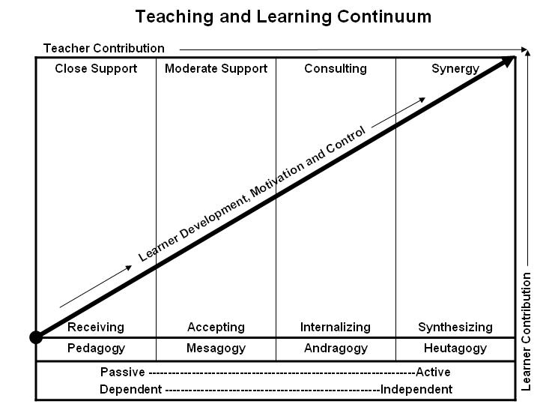
Learner’s Knowledge, Skills and Abilities
Indicator | Key Terms | Description
1 | Limited Knowledge and Proficiency | - Recognize basic information about the subject including terms and nomenclature.  - Students must demonstrate ability to recall information such as facts, terminology or rules related to information previously taught.  - Performs simple parts of the competency. Student requires close supervision when performing the competency.
2 | Moderate Knowledge and Proficiency | - Distinguish relationships between general principles and facts. Adopts prescribed methodologies and concepts.  - Students must demonstrate understanding of multiple facts and principles and their relationships, and differentiate between elements of information. Students state ideal sequence for performing task.  - Performs most parts of the competency with instructor assistance as appropriate.
3 | Advanced Knowledge and Proficiency | - Examines conditions, findings, or other relevant data to select an appropriate response.  - The ability to determine why and when a particular response is appropriate and predict anticipated outcomes.  - Students demonstrate their ability to seek additional information and incorporate new findings into the conclusion and justify their answers.  - Performs all parts of the competency without instructor assistance.
4 | Superior Knowledge and Proficiency | - Assessing conditions, findings, data, and relevant theory to formulate appropriate responses and develop procedures for situation resolution. Involves higher levels of cognitive reasoning.  - Requires students to formulate connections between relevant ideas and observations.  - Students apply judgments to the value of alternatives and select the most appropriate response.  - Can instruct others how to do the competency.  - Performs competency quickly and accurately.
A | Affective Objective | - Describes learning objectives that emphasize a feeling tone, an emotion, or a degree of acceptance or rejection.  - Objectives vary from simple attention to selected phenomena to complex but internally consistent qualities of character and conscience.  - Expressed as interests, attitudes, appreciations, values, and emotional sets or biases.

